**Experiment - 6**

**Microprocessor Trainer Kit**

Aim

Study and work on DYNA-85L kit.

Hardware Required

DYNA-85L trainer kit, connecting wires, keyboard.

Theory

The Dyna-85L is an easy-to-use, entry level, Microprocessor trainer kit. The Dyna-85A kit has Intel's 8085 microprocessor @ 3 MHz together with 8255 as well as 8155 chips onboard. This allows the user to learn all the required peripheral chips together with its 4Kb powerful firmware, it is one of the best products to learn microprocessors especially the 8085 chips.

Features -:

* High performance 8085A CPU @ 3 MHz •
* 4 K powerful monitor FIRMWARE. Including all standard commands, codes, functions and utility subroutines besides Assembler and dissembler.
* 8 K user RAM 6264.
* Three 28 pin sockets provided for memory expansion up to a maximum of 56 K.
* Versatile Keyboard/Display controller using 8279.
* 46 parallel I/O lines, 22 from 8155 and 24 from 8255.
* Serial I/O through auto adjusting type RS-232 channel. This connector is conveniently brought on the rear
* Built-in audio cassette interface.
* Programmable timer.
* Powerful 8085 interrupt capabilities.
* 2 X 40 LCD Display, bright & backlit for easy operations from wide angle.
* 104 Key standard PC-compatible keyboards.
* All address, data and control and hardware interrupt lines are brought out on a 50 pin FRC connector for system interfacing and expansion.
* All Dyna Study Cards are supported by this trainer kit •
* Three 16-bit Timer/Counter channels are available on-board, using 8253.
* These channels are available on a 10 pin FRC connector.
* RAM sockets are provided with battery backup.
* Supplied in attractive enclosure.

.

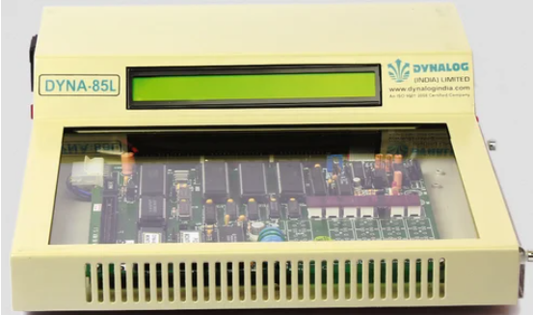

(DYNA-85L trainer kit)

**Codes:**

|  |  |
| --- | --- |
| **(Show the data byte 32H into memory location 4000H)**  A C000H  MVI A, 32H  STA 4000H  HLT | **(ADD)**  LXI H, C050  MOV A, M  INX H  ADD M  INX H  MOV M, A  HLT |
| **(Subtract operation)**  LXI H,2000H  MOV A, M  LXI H,400H  SUB M  INX H  MOV M, A  HLT | **(1’s complement)**  LDA C050H  CMA  STA C055H  HLT |
| **(2’s complement)**  LDA C100H  CMA  ADI 01H  STA C105H  HLT | **(Shift in eight-bit data’s 4 bit is right. Assume that data is in register C)**  MOV A, C  RAR  RAR  RAR  RAR  MOV C, A  HLT |

**Outputs:**

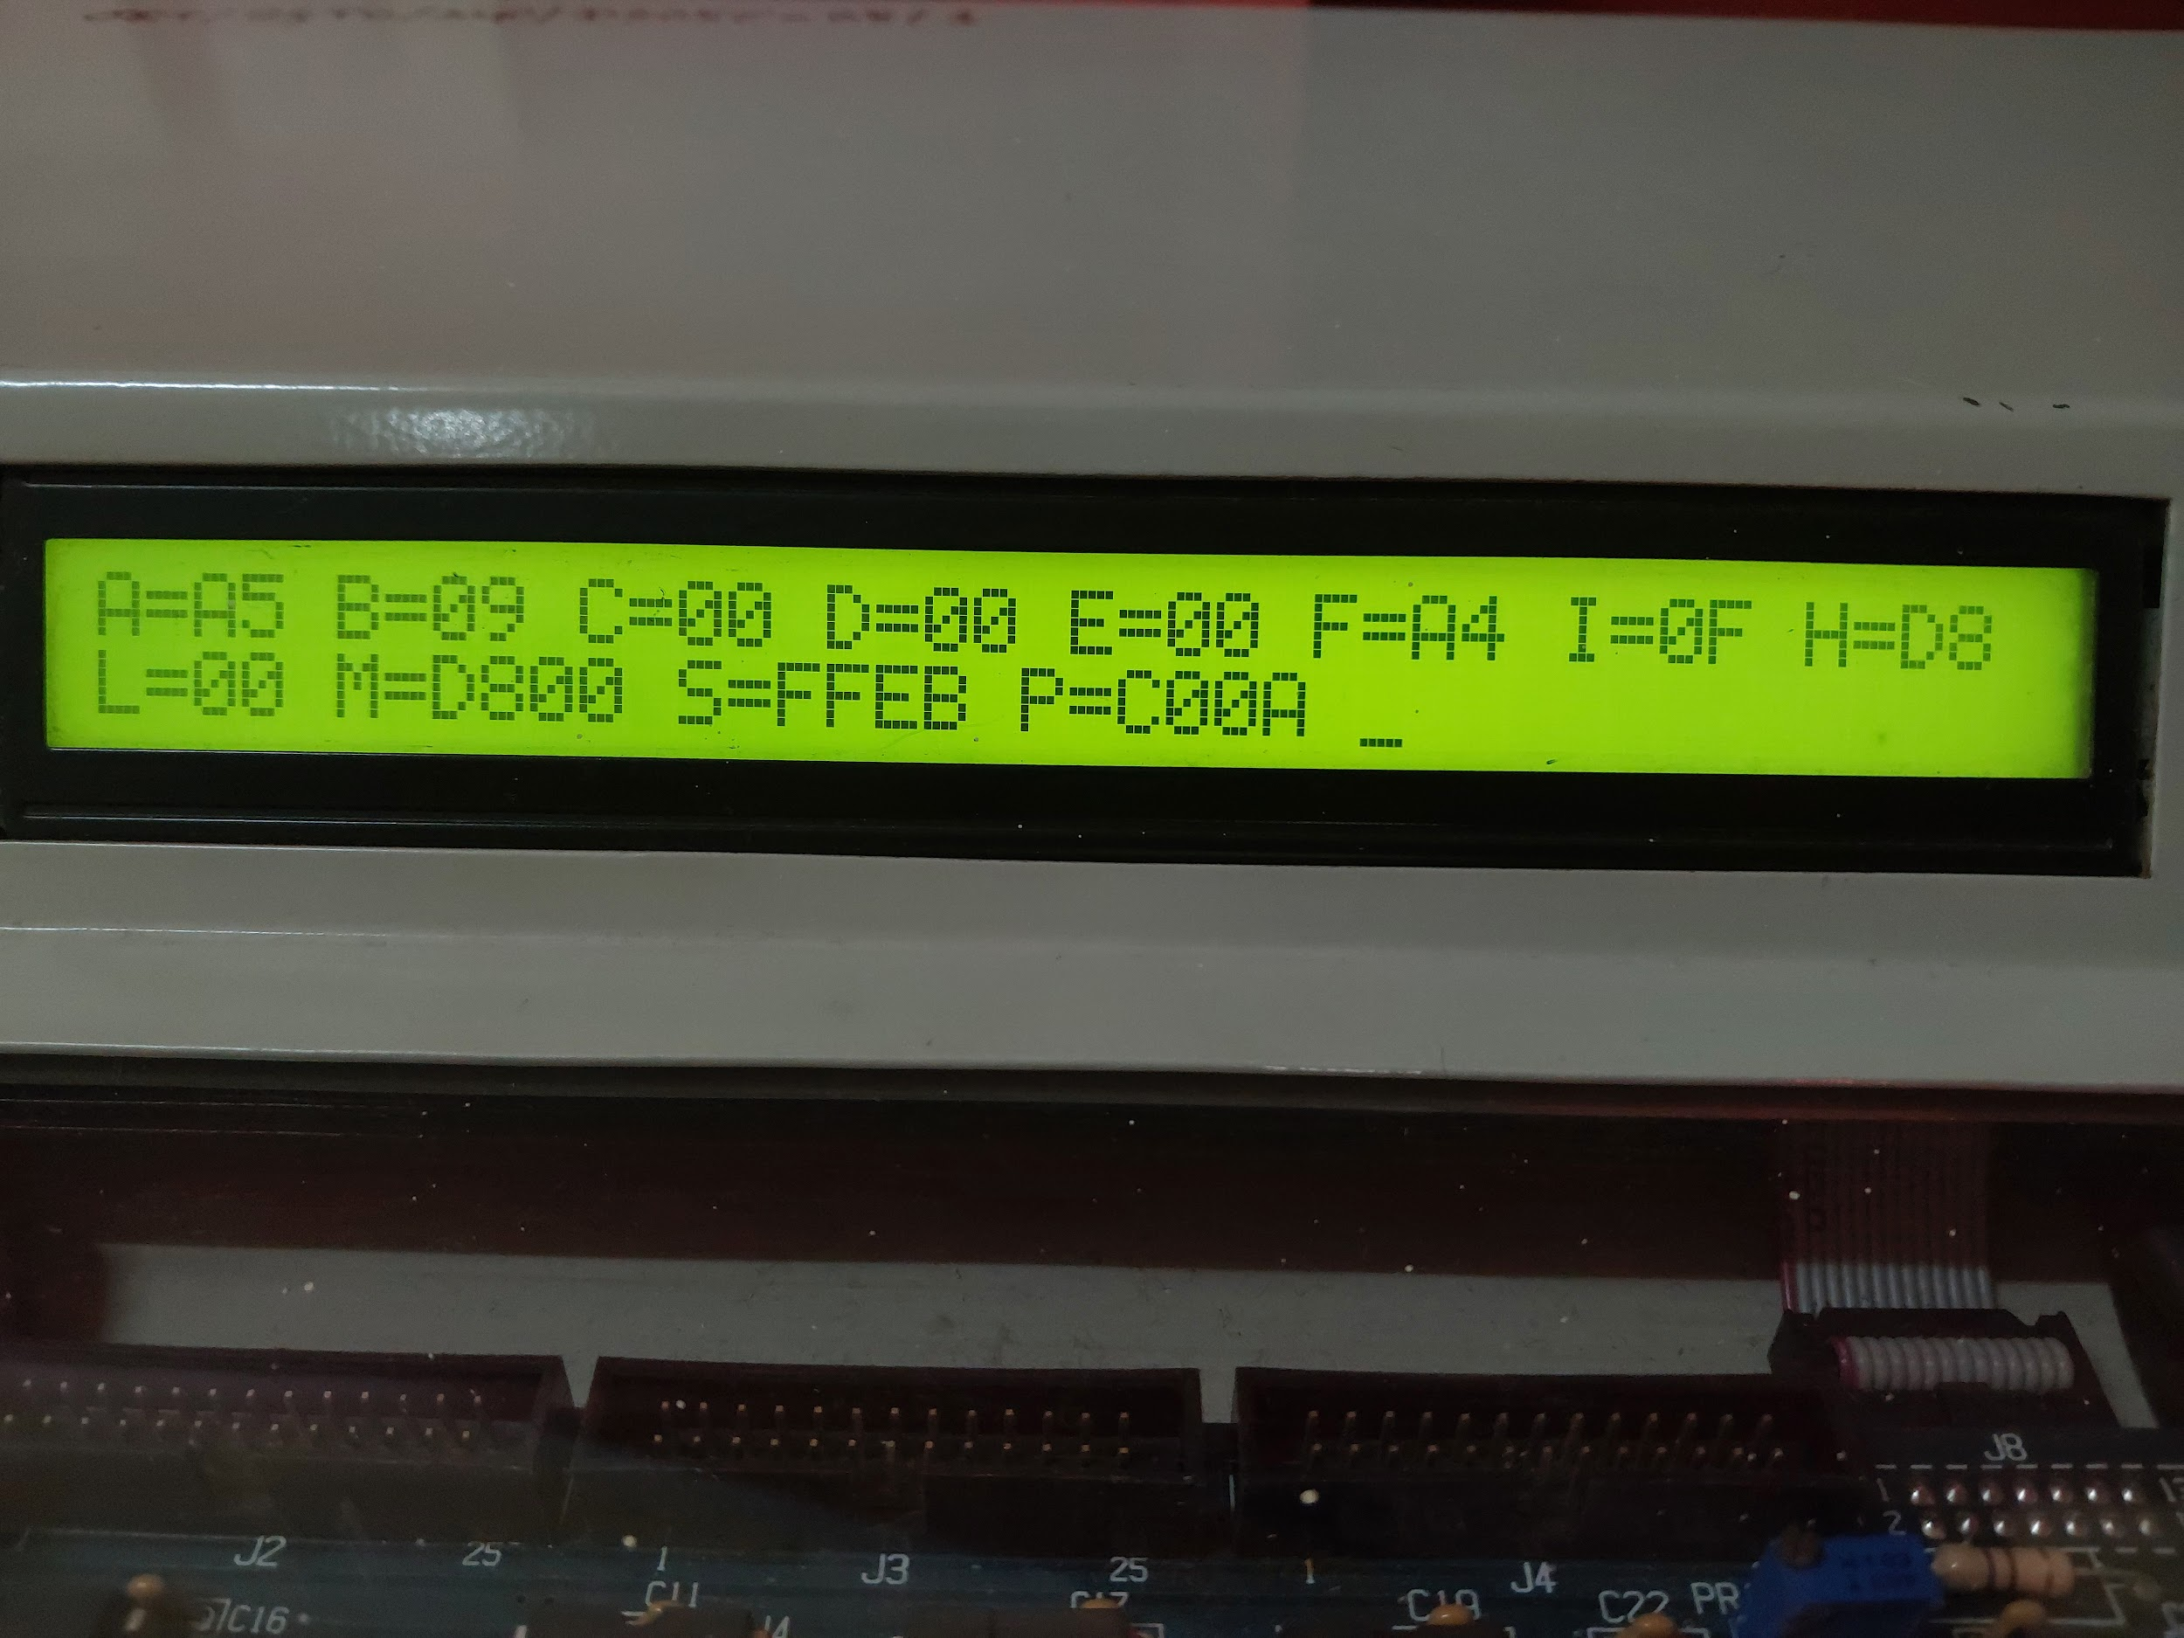

(1’s Complement)

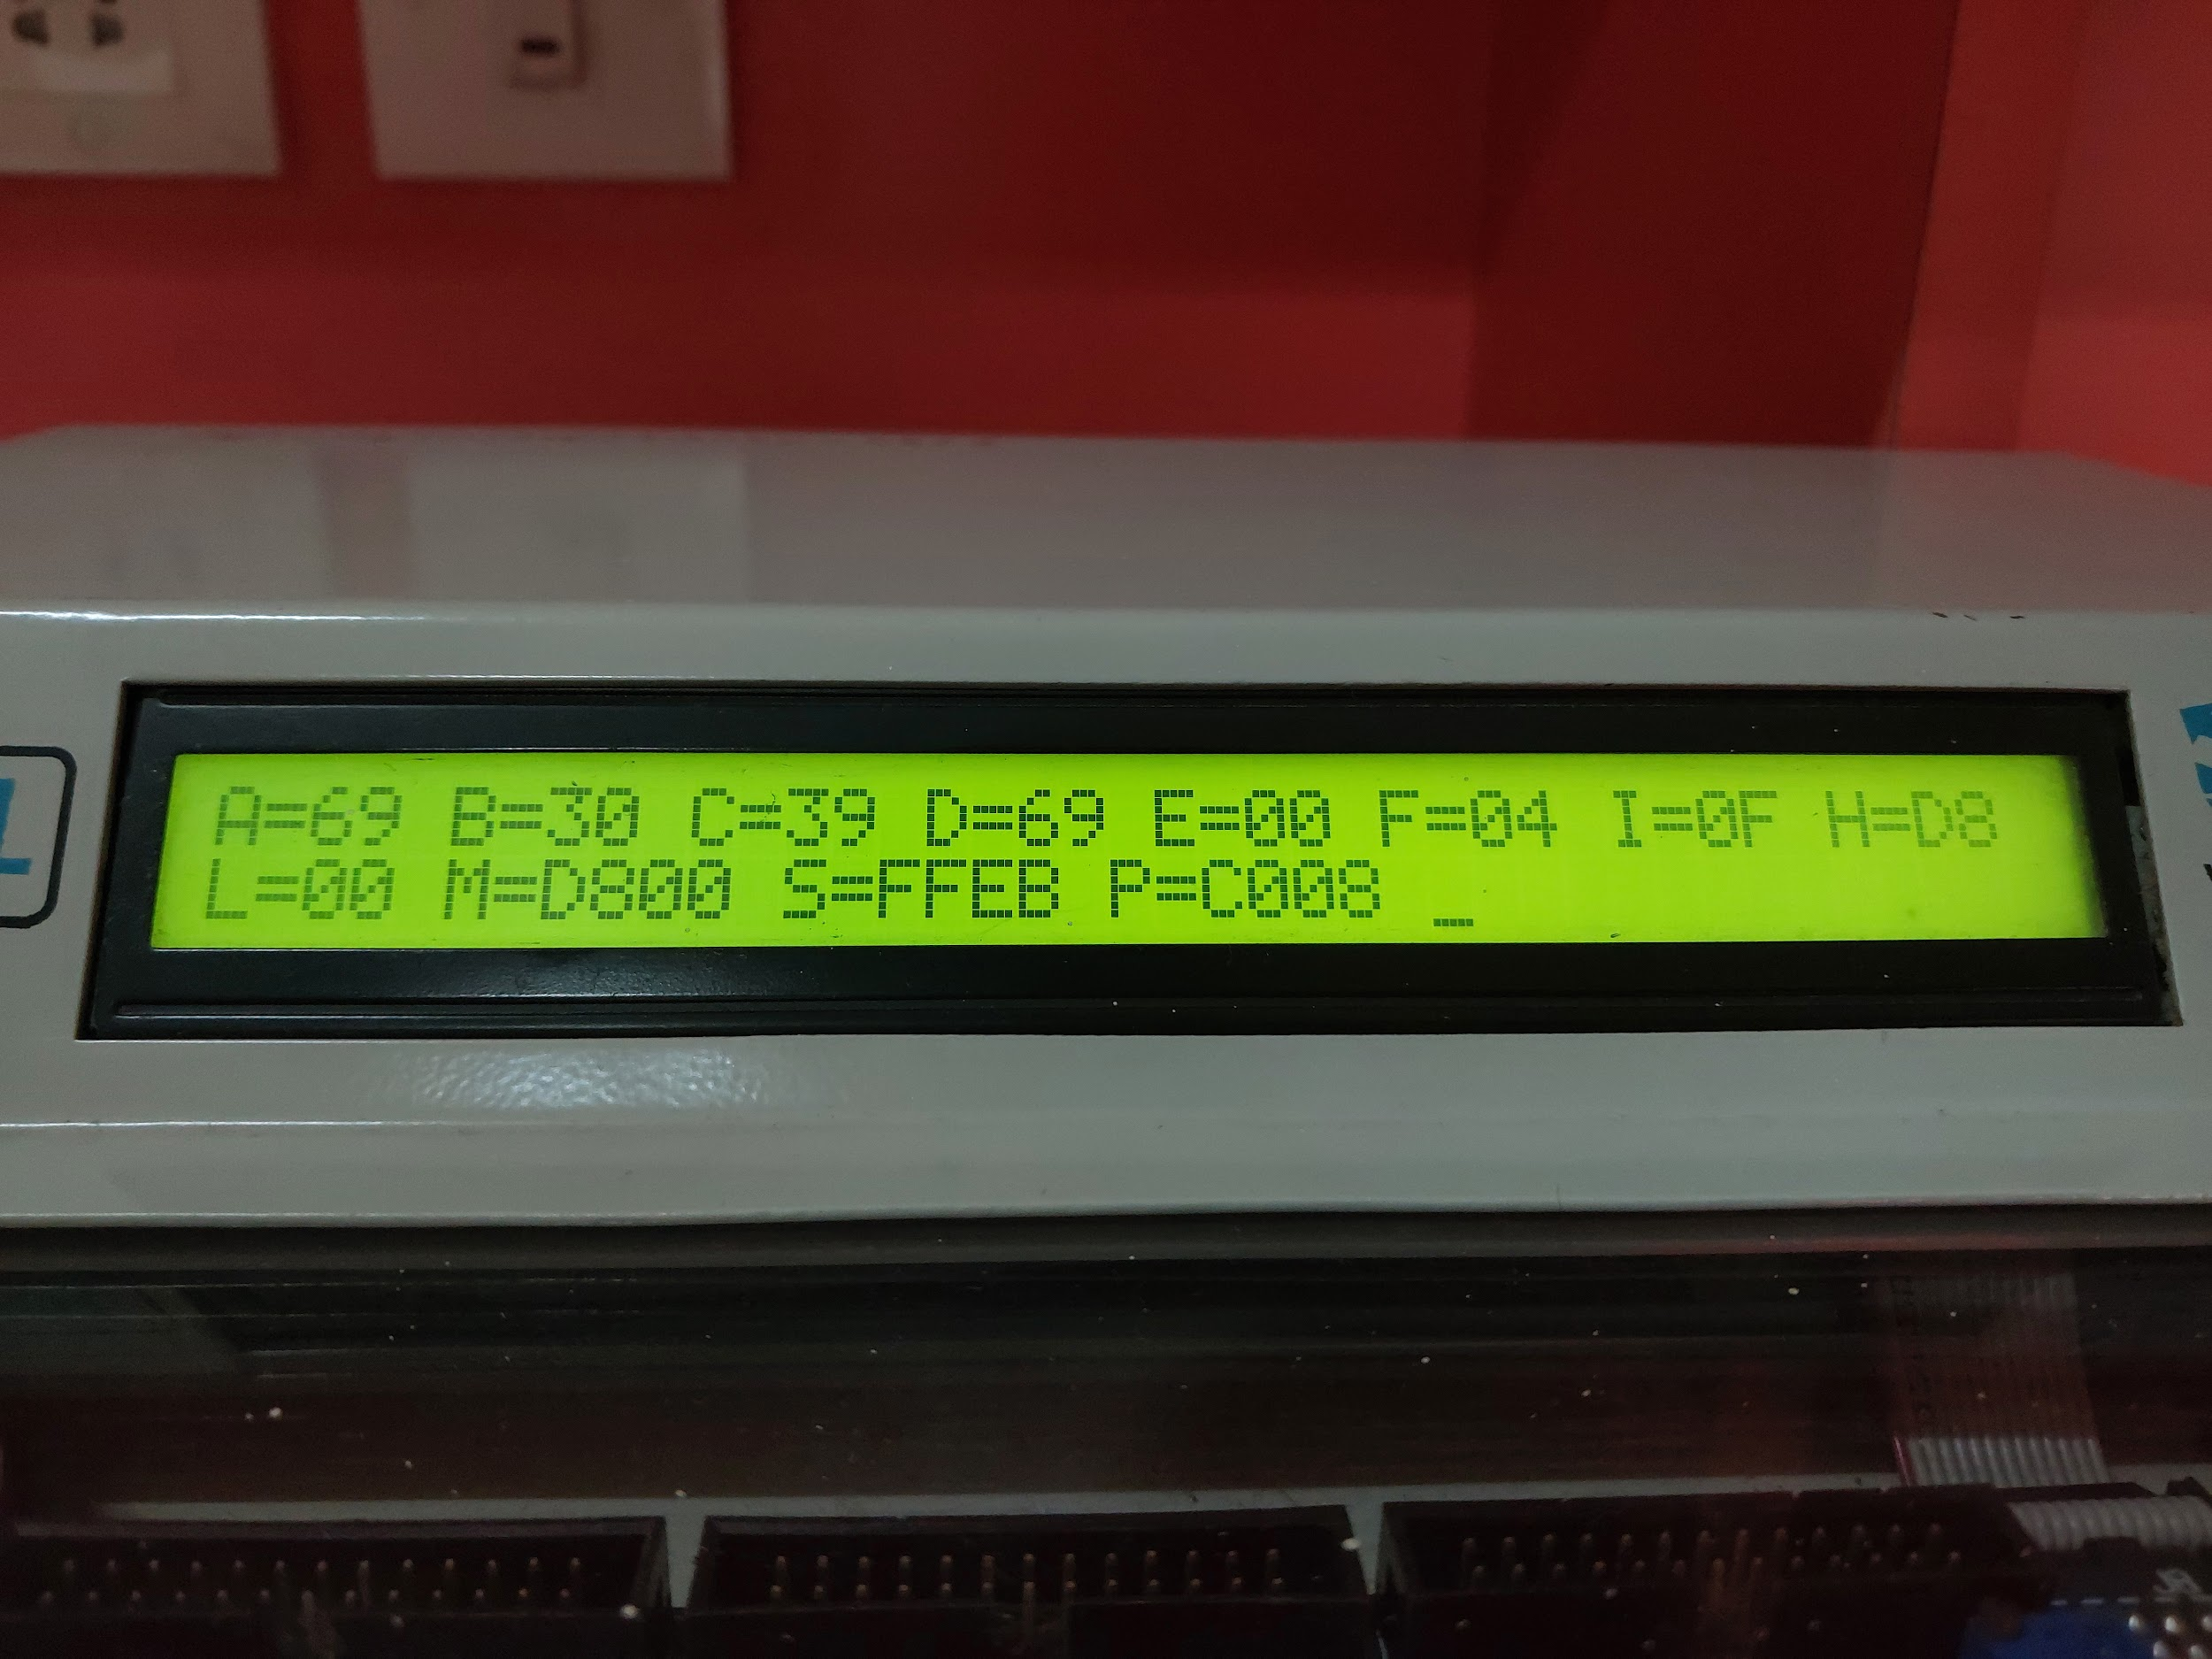

(Addition)

**Conclusion:**

The DYNA-85L microprocessor trainer kit has equipped us with practical experience in electronics and hardware design. The 8085 microprocessor, integral to this kit, supports a comprehensive instruction set that includes commands such as Add, Sub, Move, among others. These commands are incorporated into a programming language that facilitates a range of operations. Thanks to its sophisticated instruction set, this microprocessor is capable of executing complex tasks.